Selenium Frameworks | POM | PART - 1 | WHY and WHAT about Page Object Model | Sample Implementation

Selenium's POM (Page Object Model is more of a Design Pattern than a framework). However, a majority of the selenium community has accepted the Page Object Model as a Framework. Hence, I'm also using the same term.
Application Under Test : https://opensource-demo.orangehrmlive.com/web/index.php/auth/login
What will we learn in this video?
1. Why Page Object Model is needed for Selenium Projects?
2. What is Page Object Model?
3. How to achieve the Page Object Model?
4. Building a sample project from scratch for POM structure.

Element in the UI page is subject to change..do we keeping the element property outside.whenever changes happen..its easy to maintain & track
How testdata we are reading from excel sheet..same way we are keeping element property outside of the test cases

Based on the page name, we are storing the elements related for that particular page separately[in one class]..
Login page to store only element related to login page
Home page to store only element related to Home page
In further if any changes happen..then user can go directly and update easily, else he need to go all the test cases and check the elements & modify
Create a java project[PageObject model]
2 package -> 1 for Page object & 1 for test cases
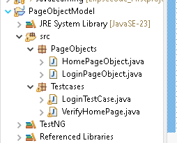
1.LoginPageobject
package PageObjects;
import org.openqa.selenium.By;
import org.openqa.selenium.WebDriver;
import org.openqa.selenium.WebElement;

public class LoginPageObject {

//static using, bec its easy to get the webelement in another class without creating objects
//instead of void, we are using WebElement..return type is WebElement
//WebDriver Driver need to use...to address WebDriver to use driver.findelement else throw error
public static WebElement username(WebDriver Driver) {
return Driver.findElement(By.name("username"));
}

public static WebElement Password(WebDriver Driver) {
return Driver.findElement(By.name("password"));
}

public static WebElement Submitbtn(WebDriver Driver) {
return Driver.findElement(By.xpath("//button"));
}
}

LoginTestcase [Just login & close]
package Testcases;

import java.time.Duration;

import org.openqa.selenium.By;
import org.openqa.selenium.WebDriver;
import org.openqa.selenium.WebElement;
import org.openqa.selenium.chrome.ChromeDriver;
import org.openqa.selenium.support.ui.ExpectedConditions;
import org.openqa.selenium.support.ui.WebDriverWait;
import org.testng.annotations.Test;

import PageObjects.LoginPageObject;

public class LoginTestCase {

@Test
public void Login() {
System.out.println("Hello Suku");

System.setProperty(
"webdriver.chrome.driver",
"C:\\Users\\user\\Downloads\\chromedriver.exe");
// Instantiate a ChromeDriver class.
WebDriver driver = new ChromeDriver();

// Maximize the browser
driver.manage().window().maximize();

// Launch Website
driver.get("https://opensource-demo.orangehrmlive.com/web/index.php/auth/login");

//wait
WebDriverWait driverWait = new WebDriverWait(driver, Duration.ofSeconds(30));
driverWait.until(ExpectedConditions.visibilityOfAllElementsLocatedBy(By.name("username")));

//classname.elementname..action
LoginPageObject.username(driver).sendKeys("Admin");
LoginPageObject.Password(driver).sendKeys("admin123");
LoginPageObject.Submitbtn(driver).click();

driver.close();
}

}

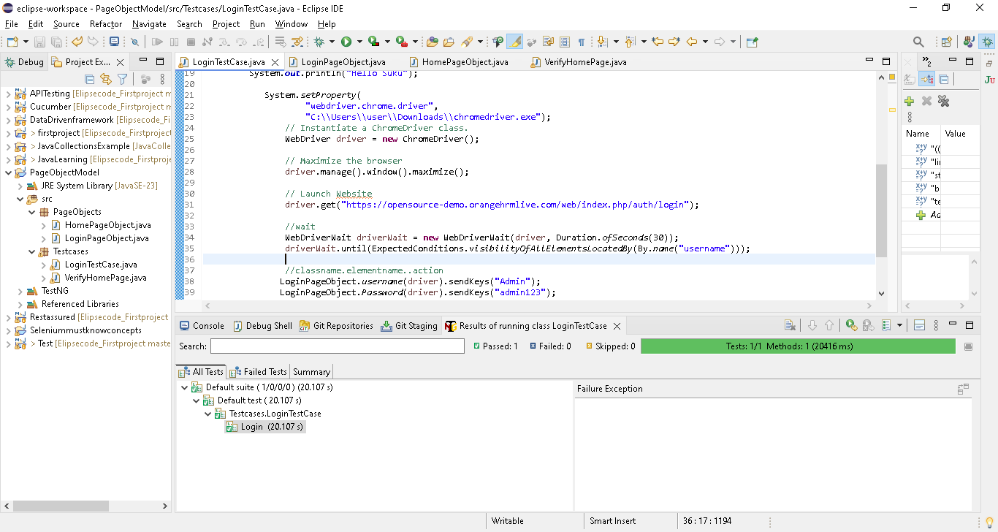

2.HomePageobject
package PageObjects;

import org.openqa.selenium.By;
import org.openqa.selenium.WebDriver;
import org.openqa.selenium.WebElement;

public class HomePageObject {

//static using, bec its easy to get the webelement in another class without creating objects
//instead of void, we are using WebElement..return type is WebElement
//WebDriver Driver need to use...to address WebDriver to use driver.findelement else throw error
public static WebElement Adminlink(WebDriver Driver) {
return Driver.findElement(By.xpath("//span[text()='Admin']"));
}

public static WebElement LeaveBtn(WebDriver Driver) {
return Driver.findElement(By.xpath("//span[text()='Leave']"));
}

}

VerifyHomePageTest case [Login & verify]
package Testcases;

import PageObjects.HomePageObject;
import PageObjects.LoginPageObject;

import java.time.Duration;

import org.openqa.selenium.By;
import org.openqa.selenium.WebDriver;
import org.openqa.selenium.WebElement;
import org.openqa.selenium.chrome.ChromeDriver;
import org.openqa.selenium.support.ui.ExpectedConditions;
import org.openqa.selenium.support.ui.WebDriverWait;
import org.testng.annotations.Test;

public class VerifyHomePage {
WebDriver driver;

@Test (priority = 0)
public void Login() {
System.out.println("Hello Suku");

System.setProperty(
"webdriver.chrome.driver",
"C:\\Users\\user\\Downloads\\chromedriver.exe");
// Instantiate a ChromeDriver class.
driver = new ChromeDriver();

// Maximize the browser
driver.manage().window().maximize();

// Launch Website
driver.get("https://opensource-demo.orangehrmlive.com/web/index.php/auth/login");

//wait
WebDriverWait driverWait = new WebDriverWait(driver, Duration.ofSeconds(30));
driverWait.until(ExpectedConditions.visibilityOfAllElementsLocatedBy(By.name("username")));

//classname.elementname..action
LoginPageObject.username(driver).sendKeys("Admin");
LoginPageObject.Password(driver).sendKeys("admin123");
LoginPageObject.Submitbtn(driver).click();
}

@Test (priority = 1)
public void verifyHome() {
// Instantiate a ChromeDriver class.

//wait
WebDriverWait driverWait = new WebDriverWait(driver, Duration.ofSeconds(100));
driverWait.until(ExpectedConditions.visibilityOfAllElementsLocatedBy(By.xpath("//span[text()='Admin']")));

boolean admin = HomePageObject.Adminlink(driver).isDisplayed();
boolean logout = HomePageObject.LeaveBtn(driver).isDisplayed();

if (admin == true & logout == true) {
System.out.println("Adminlink & logoutbtn present in the home page");
} else {
System.out.println("Adminlink & logoutbtn not present in the home page");
}
}

}

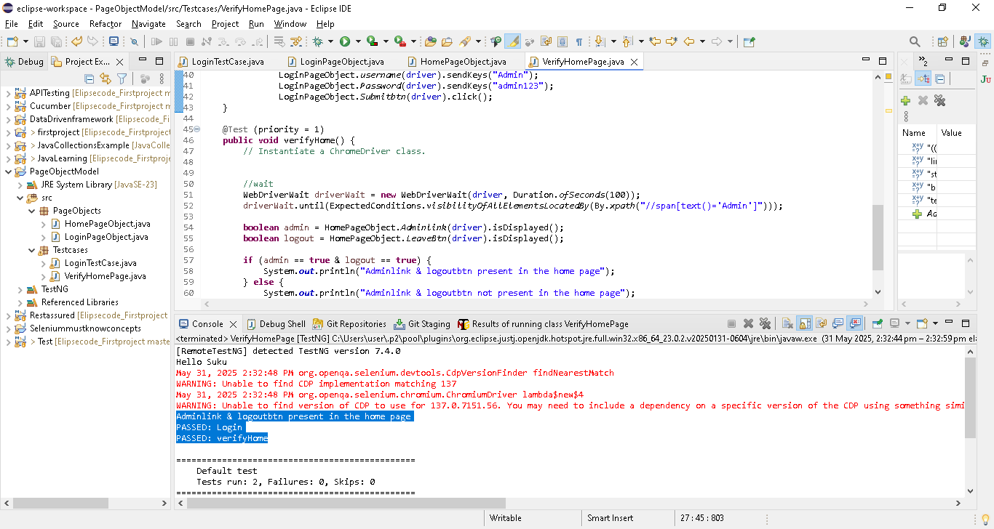

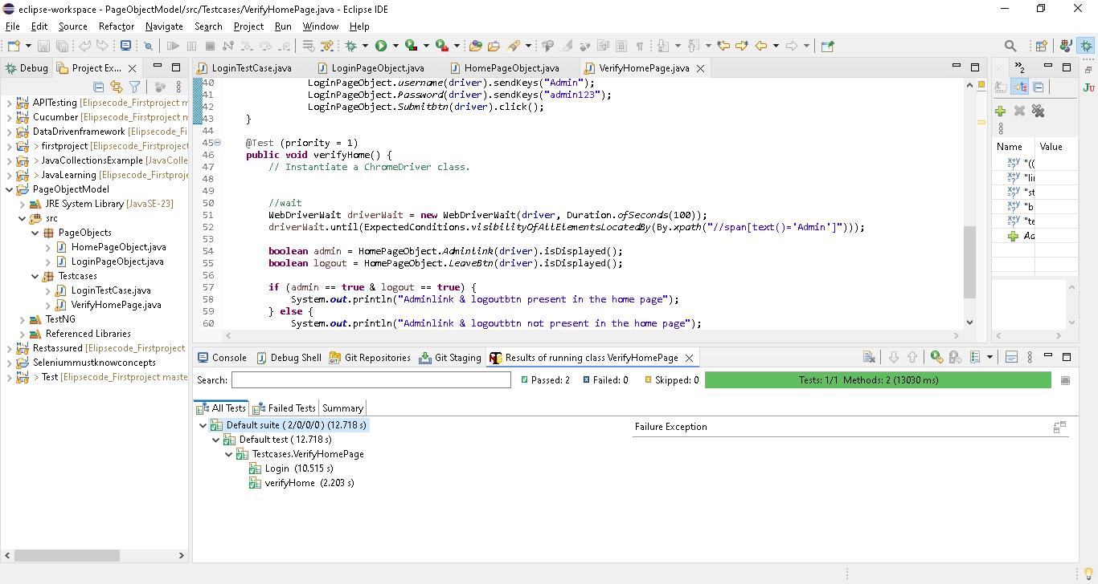

Selenium Frameworks | POM | PART - 2 | Page Factory | Page Object Model | Sample Implementation

In the previous video, we understood the concept of Page Object Model and its significance. In this video, we will implement the page object model with the help of Page Factory. "Factory" is one of the design patterns of Java. Selenium has used one of the famous design patterns called Factory design pattern and that is called Page Factory. Page Factory is the best and most suited approach for implementing the Page Object Model.
What will we learn in this video:
1. What is Page Factory?
2. @FindBy annotation
3. Init elements function of Page Factory.

Enhancing our POM project[above video] with selenium Page factory.most of the real project use this page factory approach
In interview will ask without using Findelement , how to find the elements ?
The answer is using @FindBy annotation
Pagefactoryobject
package PageFactoryobject;

import org.openqa.selenium.By;
import org.openqa.selenium.WebDriver;
import org.openqa.selenium.WebElement;
import org.openqa.selenium.support.FindBy;

public class LoginPageobjectuisnfFindby {

//static using, bec its easy to get the webelement in another class without creating objects
//we are using WebElement..object type is WebElement
//use @ findby annotation instead of driver.findelements
@FindBy (name = "username")
public static WebElement username;
@FindBy (name = "password")
public static WebElement Password;
@FindBy (xpath = "//button")
public static WebElement Submitbtn;

}

Test case
package PageFactoryTestcase;

import java.time.Duration;

import org.openqa.selenium.By;
import org.openqa.selenium.WebDriver;
import org.openqa.selenium.chrome.ChromeDriver;
import org.openqa.selenium.support.PageFactory;
import org.openqa.selenium.support.ui.ExpectedConditions;
import org.openqa.selenium.support.ui.WebDriverWait;
import org.testng.annotations.Test;

import PageFactoryobject.LoginPageobjectuisnfFindby;
import PageObjects.LoginPageObject;

public class LoginTestCasepagefactory {

@Test
public void Login() {
System.out.println("Hello Suku");

System.setProperty(
"webdriver.chrome.driver",
"C:\\Users\\user\\Downloads\\chromedriver.exe");
// Instantiate a ChromeDriver class.
WebDriver driver = new ChromeDriver();

// Maximize the browser
driver.manage().window().maximize();

// Launch Website
driver.get("https://opensource-demo.orangehrmlive.com/web/index.php/auth/login");

//wait
WebDriverWait driverWait = new WebDriverWait(driver, Duration.ofSeconds(80));
driverWait.until(ExpectedConditions.visibilityOfAllElementsLocatedBy(By.name("username")));

//To use Page factory class in order to send the driver to page object class
//bec(LoginPageobjectuisnfFindby) in page object class , driver details not present, so need to pass
PageFactory.initElements(driver, LoginPageobjectuisnfFindby.class);

//classname.elementname..action
LoginPageobjectuisnfFindby.username.sendKeys("Admin");
LoginPageobjectuisnfFindby.Password.sendKeys("admin123");
LoginPageobjectuisnfFindby.Submitbtn.click();

// driver.close();
}

}

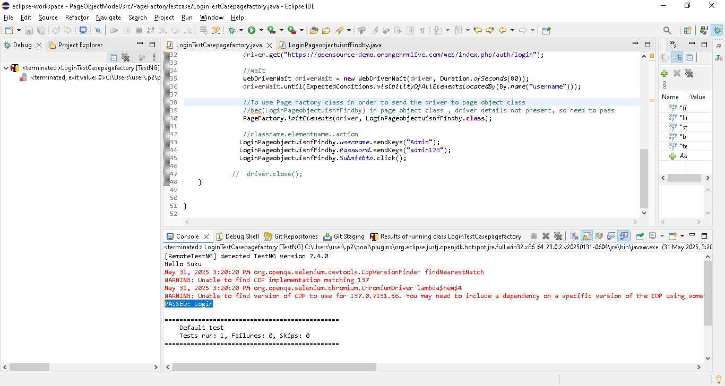

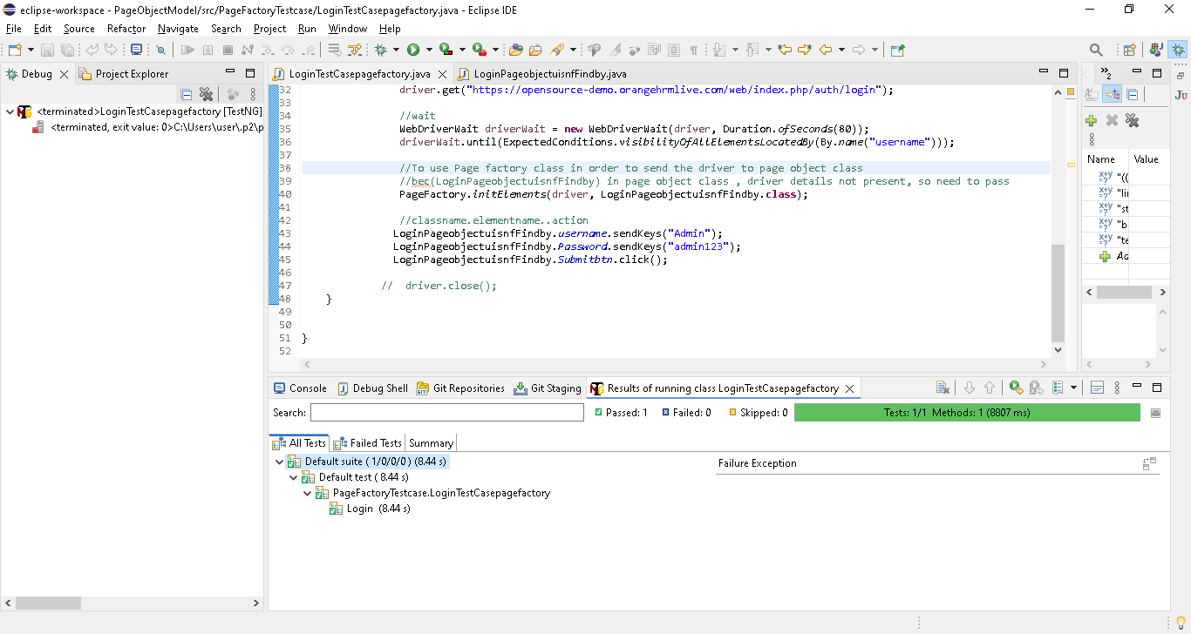

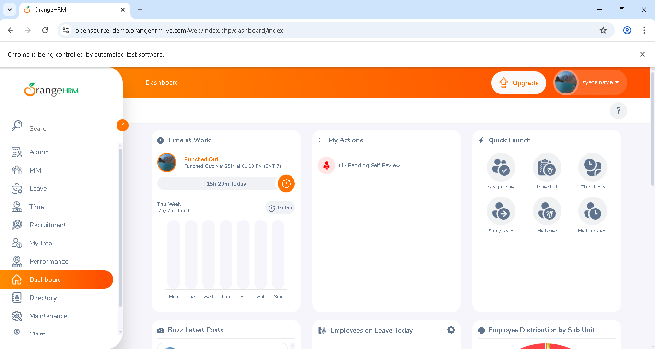

Selenium Frameworks | POM | PART - 3 | Page Factory without @FindBy| Sample Implementation

Right from the very beginning of the Selenium series, we have used findElement() method irrespective of the UI component and we have also understood we should use, ID or NAME as our first preference when locating an element. In this video, we will learn how to implement Page Factory without using the @FindBy annotation or find element method. This will give you the reason why we are always preferring ID or NAME when locating the elements.

//here we are not using find element or findby annotation
//instead of we are checking the webelement id or name in HTML page & including direct webelement id or name
//with help of pagefactory.initElements, will check the direct ID or name first in html page

Eg
For username webelement, id not present, name is present as “username”..so use as
public static WebElement username;
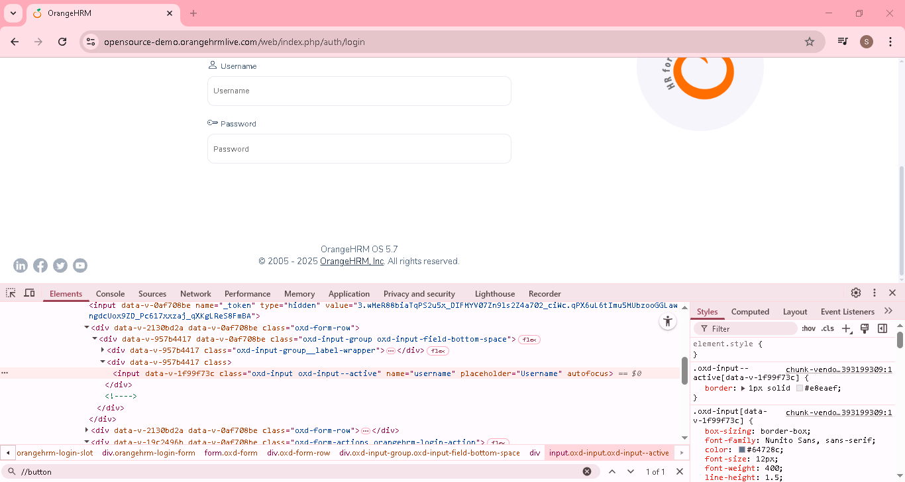
Same for password
public static WebElement password;
For login button -> no name or ID.in that case we need to use @findby only
@FindBy (xpath = "//button")
public static WebElement Submitbtn;

PageobjectwithoutFindbyanotation
package PagefactorywithoutFindbyannotation;

import org.openqa.selenium.WebElement;
import org.openqa.selenium.support.FindBy;

public class PageobjectwithoutFindbyanotation {

//here we are not using find element or findby annotation
//instead of we are checking the webelement id or name in HTML page & including direct webelement id or name
//with help of pagefactory.initElements, will check the direct ID or name first in html page
public static WebElement username;

public static WebElement password;

@FindBy (xpath = "//button")
public static WebElement Submitbtn;

}

Test case
package PagefactorywithoutFindbyannotation;

import java.time.Duration;

import org.openqa.selenium.By;
import org.openqa.selenium.WebDriver;
import org.openqa.selenium.chrome.ChromeDriver;
import org.openqa.selenium.support.PageFactory;
import org.openqa.selenium.support.ui.ExpectedConditions;
import org.openqa.selenium.support.ui.WebDriverWait;
import org.testng.annotations.Test;

import PageFactoryobject.LoginPageobjectuisnfFindby;

public class TestCase {

@Test
public void Login() {
System.out.println("Hello Suku");

System.setProperty(
"webdriver.chrome.driver",
"C:\\Users\\user\\Downloads\\chromedriver.exe");
// Instantiate a ChromeDriver class.
WebDriver driver = new ChromeDriver();

// Maximize the browser
driver.manage().window().maximize();

// Launch Website
driver.get("https://opensource-demo.orangehrmlive.com/web/index.php/auth/login");

//wait
WebDriverWait driverWait = new WebDriverWait(driver, Duration.ofSeconds(80));
driverWait.until(ExpectedConditions.visibilityOfAllElementsLocatedBy(By.name("username")));

//To use Page factory class in order to send the driver to page object class
//bec(LoginPageobjectuisnfFindby) in page object class , driver details not present, so need to pass
PageFactory.initElements(driver, PageobjectwithoutFindbyanotation.class);

//classname.elementname..action
PageobjectwithoutFindbyanotation.username.sendKeys("Admin");
PageobjectwithoutFindbyanotation.password.sendKeys("admin123");
PageobjectwithoutFindbyanotation.Submitbtn.clear();

// driver.close();
}

}

